**DAV INSTITUTE OF ENGINEERING AND TECHNOLOGY**

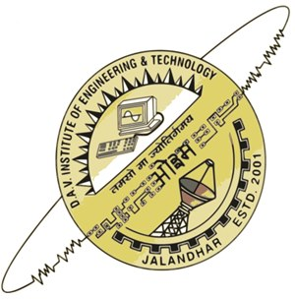

**INDUSTRIAL TRAINING FILE**

**(BTCS510)**

**SUBMITTED TO: SUBMITTED BY:**

**MRS. HARPREET BAJAJ VEDANT SAINI**

**HOD(CSE) CSE-5th SEM**

**1408447**

|  |  |
| --- | --- |
| Table of contents | |
| 1.  2.  3.  4.  5.  6.  7.  8. | Declaration  Company Profile  Introduction  Objectives  Advantages  Use and Technology  Tables and Forms  Bibliography |

**Chapter-1**

**Declaration**

We, hereby declare that the project named "Stock Manager" is authentic work carried out at SPIC - Centre of Excellence by us. We have not submitted this project and report anywhere else for award of Degree or Diploma or any other similar title.

**Vedant Saini**

**Ishita Kohli**

**Chapter-2**

**Company Profile**

The Society for Promotion of IT in Chandigarh (SPIC) has been set up under the aegis of the Department of Information Technology, Chandigarh Administration for implementing the various plans of the Administration to promote the IT industry in Chandigarh. The Chairperson of the Society is the Adviser to the Administrator.

Objectives

* To promote application of Information Technology in the Union Territory of Chandigarh in accordance with the IT Policy of Chandigarh Administration.
* To carry out all such activities that are commensurate with the IT vision of the Chandigarh Administration as outlined in IT Policy.
* To promote e-Governance, Software Exports, create IT Infrastructure, generate jobs in IT as outlined in the IT Mission of the Chandigarh Administration.
* To facilitate the establishment and functioning of data processing computer centres.
* To provide consultancy services and impart training in various disciplines of Information Technology.
* To facilitate the development of software packages as well as related items and undertake turn key project / assignments in India and abroad in Information Technology by public and private sector companies in the Union Territory of Chandigarh

**Center for Excellence(SPIC)**

SPIC and Microsoft have jointly set up a Centre of Excellence at Punjab Engineering College, Chandigarh. Under the aegis of Department of IT, SPIC and Microsoft have jointly set up a Centre of Excellence at Punjab Engineering College, Chandigarh. The Centre is a state-of-the-art Complex spread over an area of 3500 sq. ft. It consists of a spacious Conference Hall, Hi-tech class rooms, 30 work stations, a Meeting Room, and all the latest technological equipment for Training, Software Development and Presentations.

Under this understanding the partnership will work towards computerizing organizations in Chandigarh U.T., building skilled technical resources, develop expertise in providing technical consultancy, developing custom applications. Microsoft, in return will provide access to training and skills transfer on Microsoft Corporation technology.

The centre is offering various courses like MCSE, MCSD, MCDBA, VB and SQL 2000. Microsoft is carrying out training for the faculty, the students and employees of Chandigarh Administration on its new technologies / products for bench marking and demonstrating an array of Microsoft products, solutions and inter operability with other platforms at this Centre. The Centre of Excellenceis being used as a centre for the development of skills for the emerging software industry in the UT. The Center also provides organized short-term courses for corporate executives, including executives from private companies.

High-end training is carried out for the executives as per their requirement. Software engineers deployed by the Department of Information Technology and Microsoft are working on various e-governance projects, some government projects like an accounting package for the Chandigarh Pollution Control Committee, projects related to counseling/guidance (Regional Employment Officer), a project on Loan System for the Social Welfare Department, Developing a library software for the Chandigarh College of Architecture, a project for the ITI Chandigarh and also developing website of Chandigarh Administration which includes all public interacting departments of Chandigarh Administratio

**Chapter-3**

**Introduction to project**

Stock manager is a desktop application that keeps record of a firm that deals in purchasing and selling of products. It helps user to store and access every detail involved in the process of purchase as well as the sale of the product.

It includes forms that help in maintaining records related to-

1. Products and their specification
2. Current Distributors and their details
3. Customer Information
4. Purchase and Sales Details
5. Expenses involved in the transactions
6. Profit or Loss occurred to the firm
7. Stock available for the market

In this project the item targeted is books and an application is created for the purchasing, stocking, and selling of books.

Objectives

(Stock Management)

The main objective of inventory management is to maintain inventory at appropriate level to avoid excessive or shortage of inventory because both the cases are undesirable for business. Thus, management is faced with the following conflicting objectives:  
  
1. To keep inventory at sufficiently high level to perform production and sales activities smoothly.  
  
2. To minimize investment in inventory at minimum level to maximize profitability.

3. To ensure that the supply of raw material & finished goods will remain continuous so that production process is not halted and demands of customers are duly met.  
  
4. To minimize carrying cost of inventory.  
  
5. To keep investment in inventory at optimum level.  
  
6. To reduce the losses of theft, obsolescence & wastage etc.  
  
7. To make arrangement for sale of slow moving items.  
  
8. To minimize inventory ordering costs.

In this application books are taken and illustrated in stock.

Advantages

No matter the nature of your business, you need to keep track of the products your firm has on hand. Keeping an accurate inventory is critical to lowering costs and providing a more streamlined operation. As a business owner, you can rely on traditional hand counting methods or institute some form of computerized inventory control. Both approaches have their benefits and drawbacks, and it is important to weigh the relative advantages carefully.

Speed and Efficiency

A computerized inventory management system makes everything from inputting information to taking inventory easier. Doing a hand count of inventory can take days, but with a computerized inventory management system, the same process can be done in a matter of hours.

## Document Generation

Once the computerized inventory management system is in place, managers and workers can use it to automatically generate all kinds of documents, from purchase orders and checks to invoices and account statements. Managers can also use the system to automatically order products when they run low.

## Timely Data

With a manual system, the data is only as accurate and up to date as the last hand count. With a computerized inventory management system, the management team can pull a report and instantly see how many units are on the floor, how many have sold and which products are selling the fastest.

## Reliance on Technology

With a computerized inventory management system, the company is at the mercy of its technology. Outside factors like a power failure or the loss of Internet or network connectivity can render the system temporarily useless.

## Accuracy Issues

A computerized system alone does not ensure accuracy, and the inventory data is only as good as the data entry that created it. Companies that plan to use a computerized inventory management system need to have a system in place to validate their data and check the numbers reported by the system. A select hand count or targeted audit may be necessary to ensure the integrity of the system.

## Avoiding Risk of Fraud

Any computerized system carries the risk of intrusion, and with a computerized inventory management system comes the risk of fraud as well. A dishonest vendor could hack the system to receive payment for products never delivered, or a dishonest employee could redirect checks to themselves.

**Chapter-4**

**Use and Technology**

In this application Microsoft SQL server is used which has been described further -

**Microsoft SQL Server** is a relational database management system developed by Microsoft. As a database server, it is a software product with the primary function of storing and retrieving data as requested by other software applications which may run either on the same computer or on another computer across a network (including the Internet).

Microsoft markets at least a dozen different editions of Microsoft SQL Server, aimed at different audiences and for workloads ranging from small single-machine applications to large Internet-facing applications with many concurrent users.

**SQL server 2005 –**

SQL Server 2005 (formerly codenamed "Yukon") released in November 2005. It included native support for managing XML data, in addition to relational data. For this purpose, it defined an xml data type that could be used either as a data type in database columns or as literals in queries. XML columns can be associated with XSD schemas; XML data being stored is verified against the schema. XML is converted to an internal binary data type before being stored in the database. Specialized indexing methods were made available for XML data. XML data is queried using [XQuery](https://en.wikipedia.org/wiki/XQuery); SQL Server 2005 added some extensions to the T-SQL language to allow embedding XQuery queries in T-SQL. In addition, it also defines a new extension to XQuery, called XML DML, that allows query-based modifications to XML data. SQL Server 2005 also allows a database server to be exposed over web services using Tabular Data Stream (TDS) packets encapsulated within SOAP (protocol) requests. When the data is accessed over web services, results are returned as XML.

Common Language Runtime (CLR) integration was introduced with this version, enabling one to write SQL code as Managed Code by the CLR. For relational data, T-SQL has been augmented with error handling features (try/catch) and support for recursive queries with CTEs (Common Table Expressions). SQL Server 2005 has also been enhanced with new indexing algorithms, syntax and better error recovery systems. Data pages are [checksummed](https://en.wikipedia.org/wiki/Checksum) for better error resiliency, and optimistic concurrency support has been added for better performance. Permissions and access control have been made more granular and the query processor handles concurrent execution of queries in a more efficient way. Partitions on tables and indexes are supported natively, so scaling out a database onto a cluster is easier. SQL CLR was introduced with SQL Server 2005 to let it integrate with the .NET Framework.

SQL Server 2005 introduced Multi-Version Concurrency Control (MVCC). User facing features include new transaction isolation level called SNAPSHOT and a variation of the READ COMMITTED isolation level based on statement-level data snapshots.

SQL Server 2005 introduced "MARS" (Multiple Active Results Sets), a method of allowing usage of database connections for multiple purposes.

SQL Server 2005 introduced DMVs (Dynamic Management Views), which are specialized views and functions that return server state information that can be used to monitor the health of a server instance, diagnose problems, and tune performance.

Service Pack 1 (SP1) of SQL Server 2005 introduced Database Mirroring, a high availability option that provides redundancy and failover capabilities at the database level.Failover can be performed manually or can be configured for automatic failover. Automatic failover requires a witness partner and an operating mode of synchronous (also known as high-safety or full safety).Database Mirroring was included in the first release of SQL Server 2005 for evaluation purposes only. Prior to SP1, it was not enabled by default, and was not supported by Microsoft.

Extended support for SQL Server 2005 ended on April 12, 2016.

**Java –**

**Java** is a set of computer software and specifications developed by Sun Microsystems, which was later acquired by the Oracle Corporation, that provides a system for developing application software and deploying it in a [cross-platform](https://en.wikipedia.org/wiki/Cross-platform) computing environment. Java is used in a wide variety of computing platforms from embedded devices and mobile phones to enterprise servers and supercomputers. While they are less common than standalone Java applications, Java applets run in secure, sandboxed environments to provide many features of native applications and can be embedded in HTML pages.

Writing in the Java programming language is the primary way to produce code that will be deployed as byte code in a Java Virtual Machine (JVM); byte code compilers are also available for other languages, including [Ada](https://en.wikipedia.org/wiki/Ada_(programming_language)), JavaScript, Python, and Ruby. In addition, several languages have been designed to run natively on the JVM, including [Scala](https://en.wikipedia.org/wiki/Scala_(programming_language)), [Clojure](https://en.wikipedia.org/wiki/Clojure) and Groovy. Java syntax borrows heavily from C and C++, but object-oriented features are modeled after Smalltalk and Objective-C.Java eschews certain low-level constructs such as pointers and has a very simple memory model where every object is allocated on the heap and all variables of object types are references. Memory management is handled through integrated automatic garbage collection performed by the JVM.

On November 13, 2006, Sun Microsystems made the bulk of its implementation of Java available under the GNU General Public License (GPL).

The latest version is Java 8, the only supported version as of 2016.

The Java platform is a suite of programs that facilitate developing and running programs written in the Java programming language. A Java platform will include an execution engine (called a [virtual machine](https://en.wikipedia.org/wiki/Virtual_machine)), a compiler and a set of [libraries](https://en.wikipedia.org/wiki/Library_(computing)); there may also be additional [servers](https://en.wikipedia.org/wiki/Server_(computing)) and alternative libraries that depend on the requirements. Java is not specific to any processor or [operating system](https://en.wikipedia.org/wiki/Operating_system) as Java platforms have been implemented for a wide variety of hardware and operating systems with a view to enable Java programs to [run identically](https://en.wikipedia.org/wiki/Write_once,_run_anywhere) on all of them. Different platforms target different classes of device and [application domains](https://en.wikipedia.org/wiki/Application_domain):

* [Java Card](https://en.wikipedia.org/wiki/Java_Card): A technology that allows small Java-based applications ([applets](https://en.wikipedia.org/wiki/Applet)) to be run securely on [smart cards](https://en.wikipedia.org/wiki/Smart_card) and similar small-memory devices.
* [Java ME](https://en.wikipedia.org/wiki/Java_ME) (Micro Edition): Specifies several different sets of libraries (known as profiles) for devices with limited storage, display, and power capacities. It is often used to develop applications for mobile devices, PDAs, TV [set-top boxes](https://en.wikipedia.org/wiki/Set-top_boxes), and printers.
* [Java SE](https://en.wikipedia.org/wiki/Java_SE) (Standard Edition): For general-purpose use on desktop PCs, servers and similar devices.
* [Java EE](https://en.wikipedia.org/wiki/Java_EE) (Enterprise Edition): Java SE plus various APIs which are useful for [multi-tier](https://en.wikipedia.org/wiki/N-tier) [client–server](https://en.wikipedia.org/wiki/Client%E2%80%93server) [enterprise applications](https://en.wikipedia.org/wiki/Enterprise_application).

The Java platform consists of several programs, each of which provides a portion of its overall capabilities. For example, the Java compiler, which converts Java source code into Java bytecode (an intermediate language for the JVM), is provided as part of the [Java Development Kit](https://en.wikipedia.org/wiki/Java_Development_Kit) (JDK). The [Java Runtime Environment](https://en.wikipedia.org/wiki/Java_Runtime_Environment) (JRE), complementing the JVM with a [just-in-time (JIT) compiler](https://en.wikipedia.org/wiki/Just-in-time_compilation), converts intermediate bytecode into native machine code on the fly. The Java platform also includes an extensive set of libraries.

The essential components in the platform are the Java language compiler, the libraries, and the runtime environment in which Java intermediate bytecode executes according to the rules laid out in the virtual machine specification.

Java Virtual Machine

The heart of the Java platform is the concept of a "virtual machine" that executes [Java bytecode](https://en.wikipedia.org/wiki/Java_bytecode) programs. This bytecode is the same no matter what hardware or operating system the program is running under. There is a JIT (Just In Time) compiler within the *Java Virtual Machine*, or JVM. The JIT compiler translates the Java bytecode into native processor instructions at run-time and caches the native code in memory during execution.

The use of bytecode as an intermediate language permits Java programs to run on any platform that has a virtual machine available. The use of a JIT compiler means that Java applications, after a short delay during loading and once they have "warmed up" by being all or mostly JIT-compiled, tend to run about as fast as native programs.Since JRE version 1.2, Sun's JVM implementation has included a just-in-time compiler instead of an interpreter.

Although Java programs are cross-platform or platform independent, the code of the Java Virtual Machines (JVM) that execute these programs is not. Every supported operating platform has its own JVM.

Java Development Kit

The *Java Development Kit* (*JDK*) is a Sun product aimed at Java developers. Since the introduction of Java, it has been by far the most widely used Java software development kit (SDK). It contains a Java compiler, a full copy of the Java Runtime Environment (JRE), and many other important development tools.

**Chapter -5**

**Design of Project**

**ER Diagram**

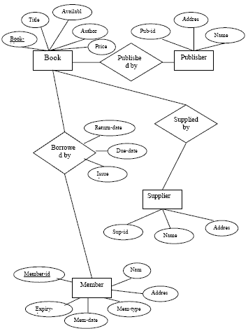

**Data Flow Diagram:**

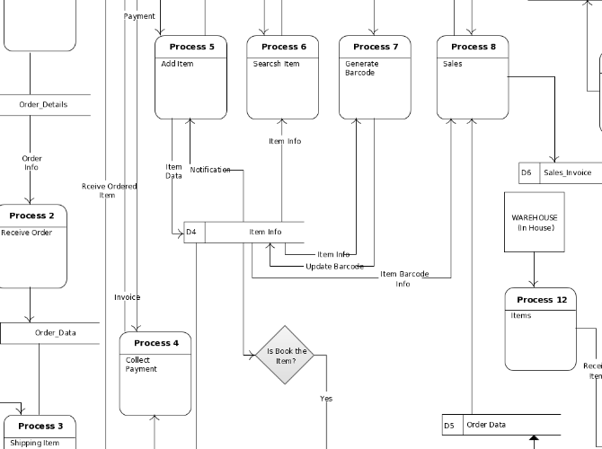

**Chapter-6**

**Screenshots Of Forms**

1. STOCKMANAGER:

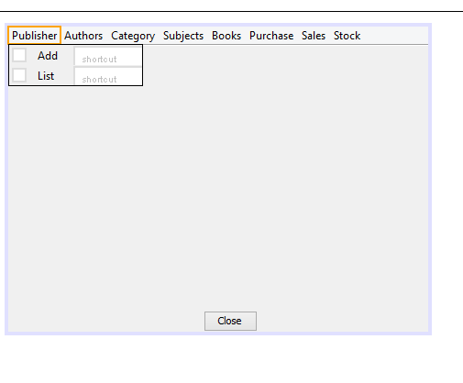

This form is the main form named stock manager .It act as the gateway to various forms such as publishers, authors, category ,subjects etc. When you click publisher you get two options i.e. add and list. By clicking add you can add various details into different forms and by list option you can see various details that you have added .List form includes buttons such as edit, delete and close which helps to edit and delete the wrong entries.

2. PUBLISHERS:

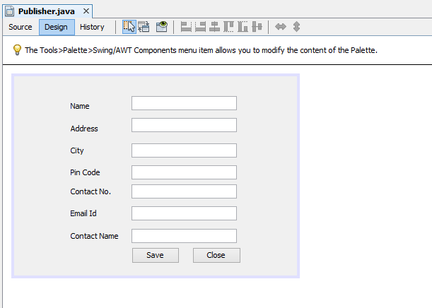

This form helps to add various details of publishers. This form includes various labels and text fields such as name,address,city,pin code,contact number,email id, contact name.This includes two buttons i.e. Save and Close.

Save helps to save the details of publisher into database and close helps to close the form by coding this.dispose().

all these buttons work according to the java coding that has been done in netbeans thus successfully adding all the details.

3. PUBLISHER LIST:

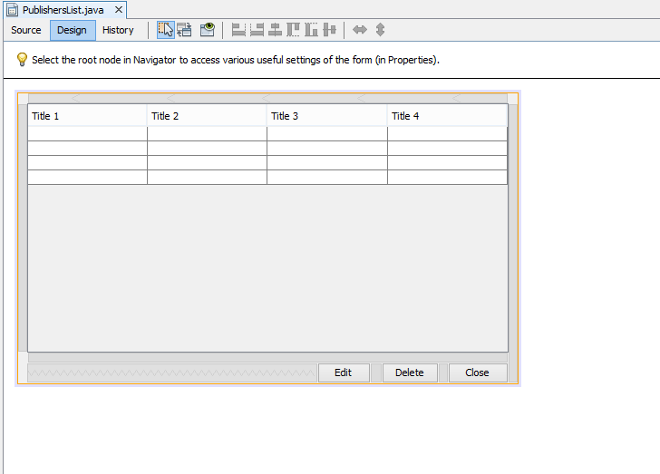

This form named publisher list helps to list all the details that has been added into the publisher form. The title includes publisher Id which is maintained at the backend ,name etc . This form includes various buttons i.e. Edit, Delete and Close. Edit helps to edit the selected entry and delete helps to delete the wrong entry and close hellps to close the form by coding maintained at the backend in netbeans.

4.AUTHORS: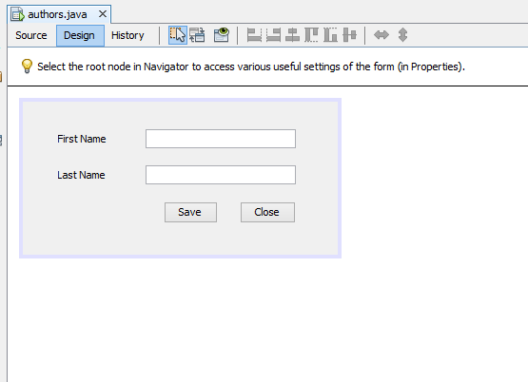

This form named Authors helps to add authors details i.e. the first and the last name of the author. The save button automatically save the detail into database named sql and close helps to close the form. When save button is clicked a message appears showing record has been saved using JOptionPane.showMessageDialog(....).All these codings are written in try and catch,if there is any wrong code in try catch helps to solve the exception.

5.AUTHOR LIST:

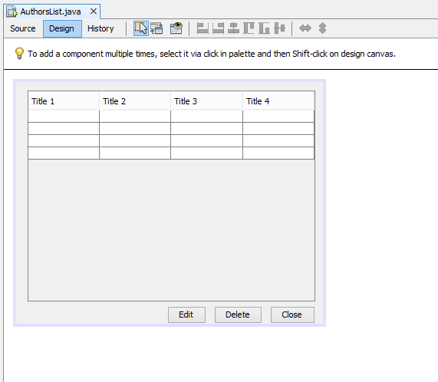

This form named AuthorsList helps to list the details that have been added in authors form. This lists various headings such as author Id,first name, last name etc. The author Id is maintained at backend which automatically links various details and sql and netbeans thus work in synchronization.the various buttons i.e. Edit, Delete and close works as edit helps to edit the selected entry , delete helps to delete the wrong entry and close helps to close the form.

6. CATEGORY:

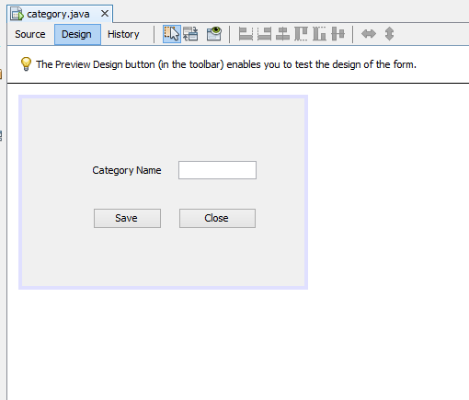

This form named Category helps to add various details of category names and thus save them into database and close button helps to close the form by coding done in netbeans.

The close button includes the coding of this.dispose() which disposes the form and finally close it.

7.CATEGORY LIST:

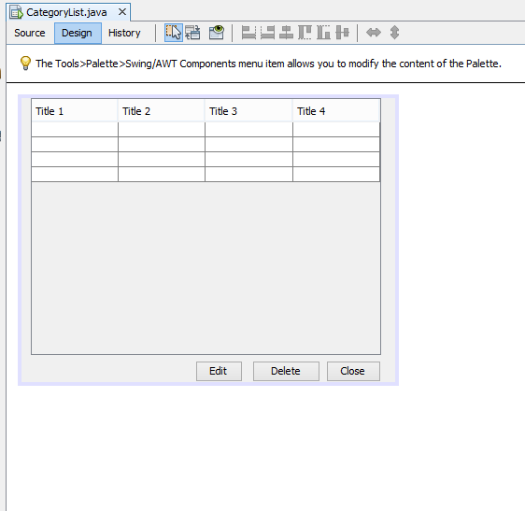

This form named Cateogory list helps to list the details maintained in category form . This form includes a category Id which was maintained at backend in database and act as the link to other forms and other headings such as category name etc. the edit button helps to edit the selected entry and delete the wrong entry that have been selected.Close finally closes the form..

8. SUBJECTS:

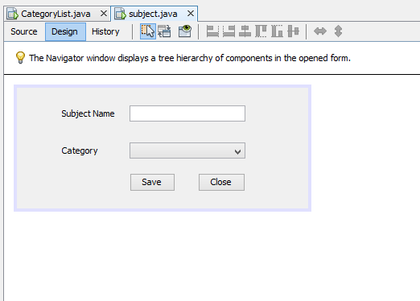

This form named Subjects includes a label called Subject name with a text field to enter data and a combobox named category which list all the categories that have been added in category form thus maintaining a link btw category and subjects. This is done by maintaining an array list of CategoryIDS which itself list the categories in the combobox. Save button saves all the details into database and Close helps to close the form.

9.SUBJECT LIST:

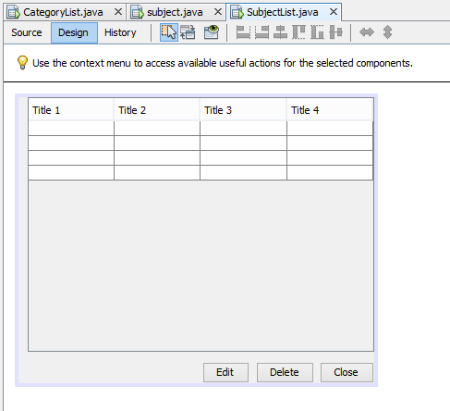

This form named SubjectList helps to list various details that has been added into subjects form such as subject name and category. This also includes a subject id which is maintained at backend and is mantained idenntity and primary key in database. The buttons such as Edit ,Delete and Close helps to edit the selected entry ,delete the wrong entry and finally close the form.

10. ADD BOOKS:

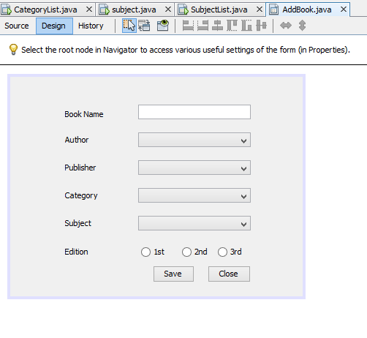

This form named AddBooks helps to add various details regarding books named book name, combo boxes such as of author,publisher,category, subject and various radio buttons of editions such as 1st, 2nd and 3rd.

This form maintains a link with other forms by Array List such as authorIds, publisherIds, categoryids. When you double click the category combo box you get to code about adding variou subjects thus all the details henc e maintained.

The save button saves all the details into database thus showing a massage of records saved and close button helps to close or dispose the form.

11. BOOKS LIST:

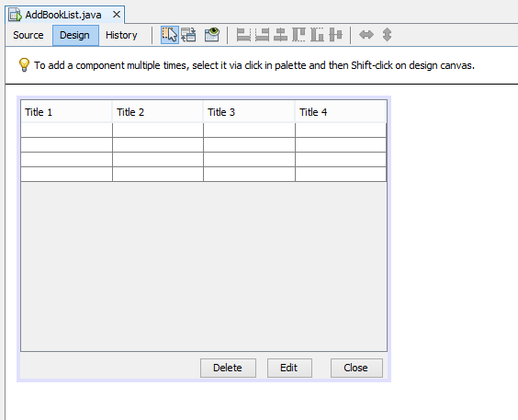

This form named AddBookList helps to list all the details added in the Addbooks form by maintaining a book id at backend. Various buttons such as delete helps to delete the wrong entry,edit the selected entry and close helps to close or dispose off the form.

12. PURCHASES:

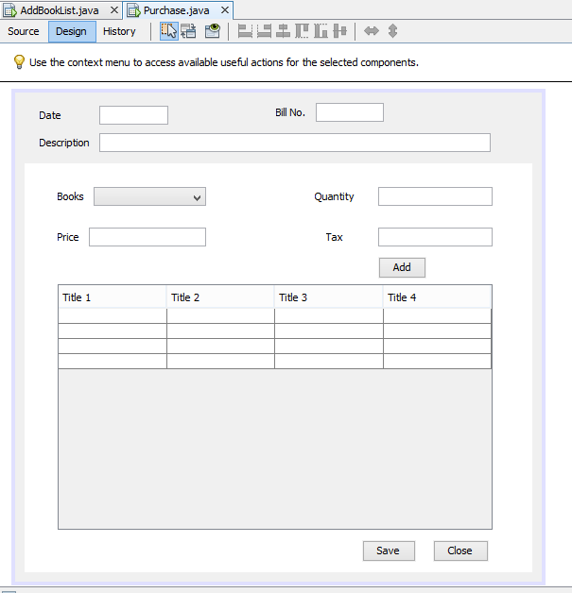

This form named Purchases includes various labels and text fields such as of date, bill no. and description. This form includes a Jpanel consisting of a combo box of books by maintaining a array lisgt of book ids , quantity, price and tax text fields. It includes a add button which when you cick add all details into the Jtable and when you click save it gets saved into database.Close helps to close the form or dispose off the phone by this.dispose() coding done in netbeans

13. PURCHASE LIST:

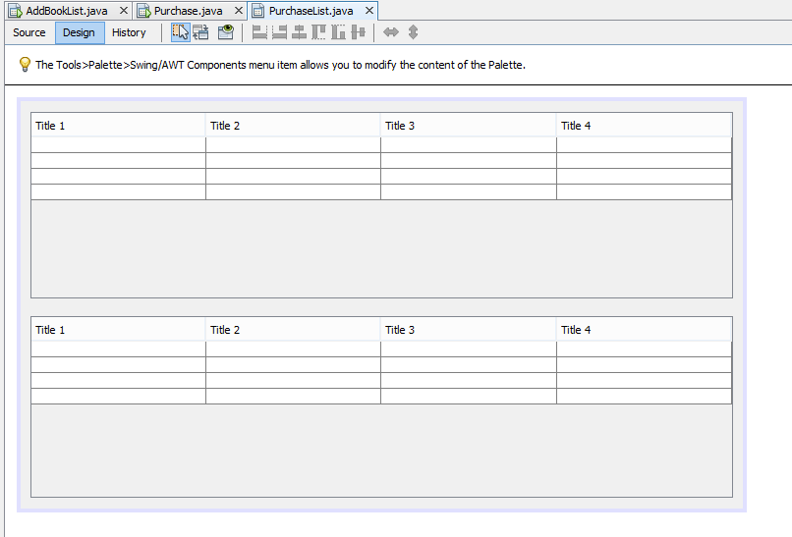

This form named Purchase list maintains two jTables . In one jTable it maintains a purchase id,bill no, date and description . When you single click that record in frst table you get detail id, book name, quantity and tax.

Thus maintaining the records in two tables and linking the information together.

14. SALES:

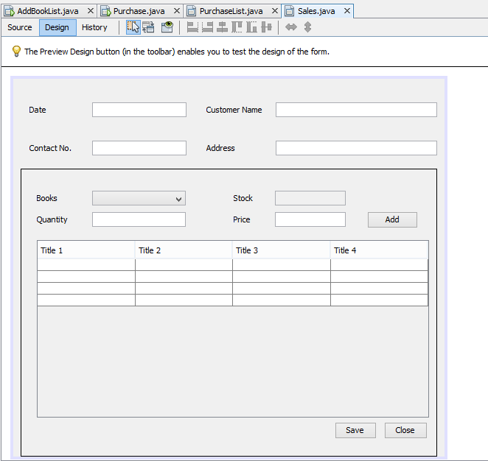

This form named Sales includes various labels and text fields such as of date, contact no., contact name and address. This form includes a Jpanel consisting of a combo box of books by maintaining a array lisgt of book ids , quantity, price and Stock text fields. It includes a add button which when you cick add all details into the Jtable and when you click save it gets saved into database.If quantity increases stock value it displays a message else it get added.Close helps to close the form or dispose off the phone by this.dispose() coding done in netbeans.

15.SALES LIST:

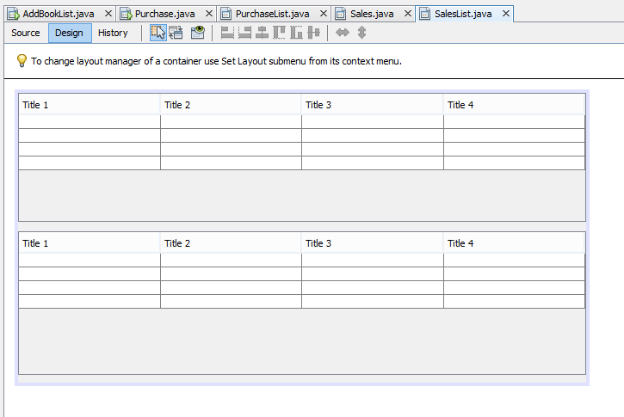

This form named Sales list maintains two jTables . In one jTable it maintains a sale id,bill no, date and description . When you single click that record in frst table you get detail id, book name amd quantity

Thus maintaining the records in two tables and linking the information together.

16. STOCK:

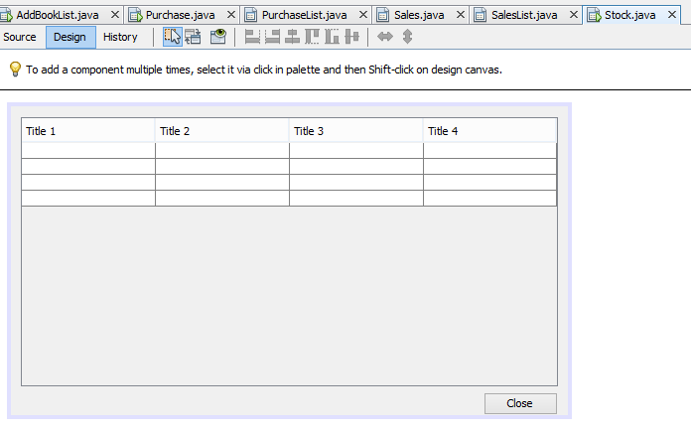

This form named stock includes one jtable which maintains a record of the stock that inlcudes a book name, amount of it which are bought, amount of it which are sold and the amount present in the stock.

Close button closes the form or disposes it off by coding maintained in netbeans.

17. PAYMENTS:

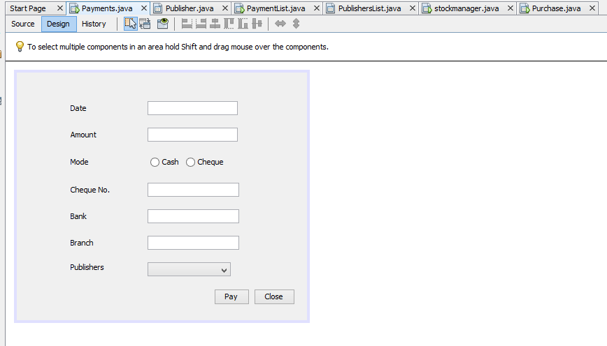

This form deals with the payment methods. It contains 5 text fields namely Date, Amount, Cheque No, Bank, Branch,2 radio buttons for the mode of payment which is cash or cheque and a Combobox which displays the names of the Publishers. When the save button is pressed all the details get saved into the database and textfields are cleared.

18. PAYMENTLIST:

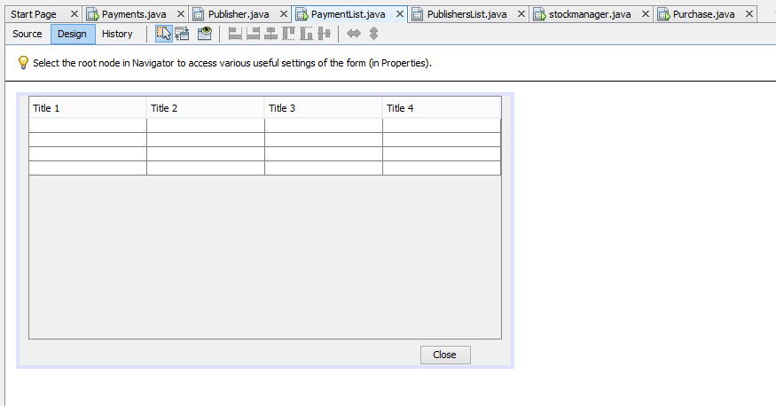

It consists of a Jtable which shows the list of al the details which has been entered into payments form.

**Chapter-7**

**Testing Report**

1. STOCKDB DATABASE:

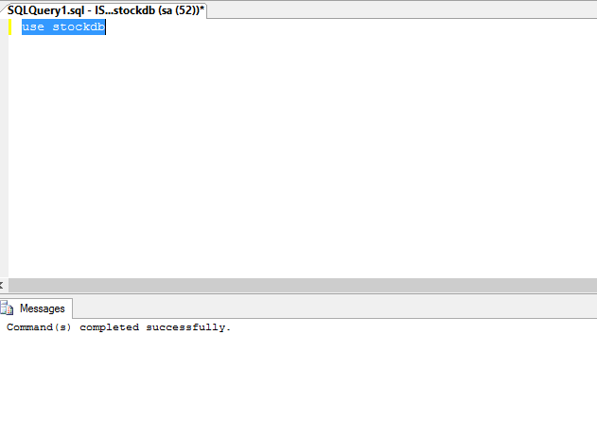

A database named stockdb is created using Query create database stockdb and then it is used in order to make connection with various tables or procedures we make.

2. PUBLISHERS:

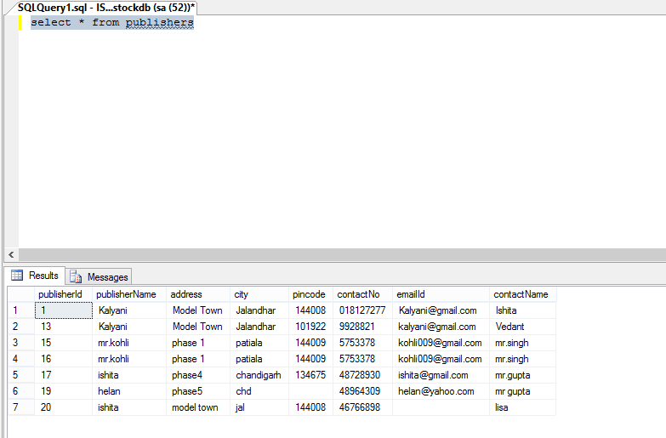

A table named publishers is made by query create table publishers(different fields) and by select * from publishers show all the details that have been added to publishers.

various fields includes:

Field Name Datatype Size

publisherId int primary key identity -

publisherName varchar 20

address varchar 50

city varchar 20

pincode varchar 6

contactNo varchar 10

email Id varchar 20

contact name varchar 20

3. AUTHORS:

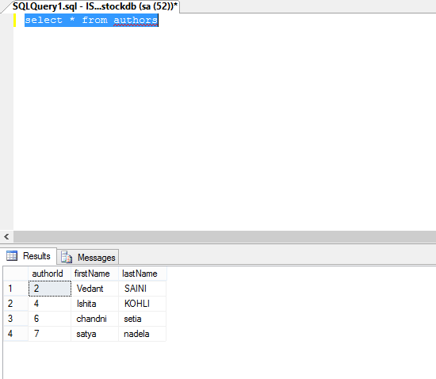

This table is created using create table authors(fields....), select * from authors shows various records that have been maintained in the table.

This table inlcudes various fields such as:

Field name Datatype Size

author id int primary key identity -

first name varchar 20

last name varchar 20

4. CATEGORY:

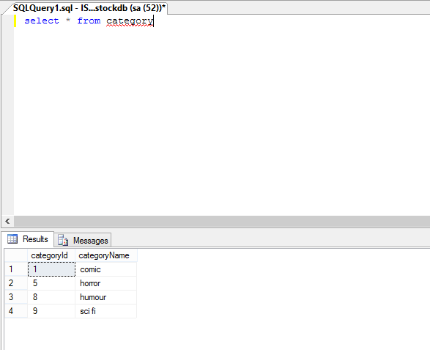

This table is created using query create table category(different fields...). Select * from category helps to view all the details present in category.

Various fields included in category table are:

Field Datatype Size

categoryId int primary key identity -

categoryName varchar 20

5. SUBJECTS:

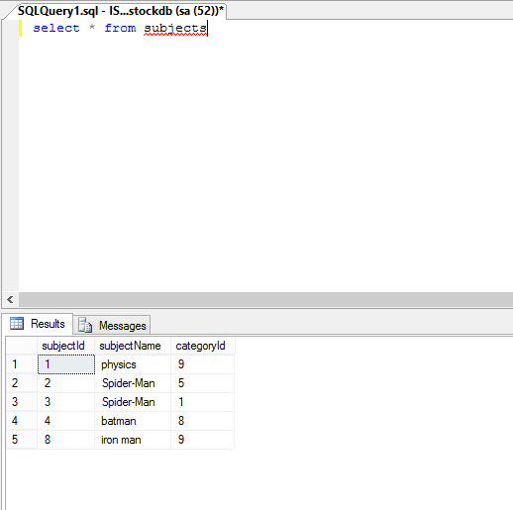

This table is created using query create table subjects(different fields...). Select * from subjects helps to view all the details present in category.

Various fields included in category table are:

Field Datatype Size

subjectId int primary key identity -

subjectyName varchar 20

categoryId int references category(categoryId) -

6. BOOKS:

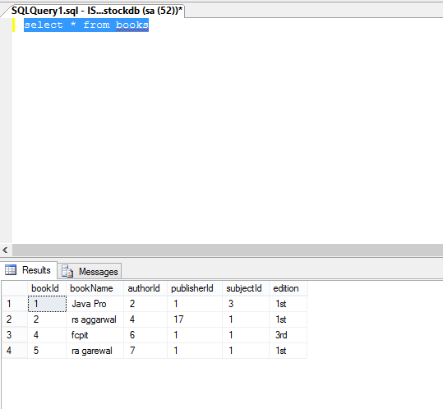

This table is created using query create table Books(different fields...). Select * from books helps to view all the details present in category.

Various fields included in category table are:

Field Datatype Size

bookId int primary key identity -

bookName varchar 20

authorId int references author(authorId) -

publisherId int references publisher(publisherId) -

subjectId int references subject(subjectId) -

edition varchar 10

7. PURCHASES:

Purchase Master:

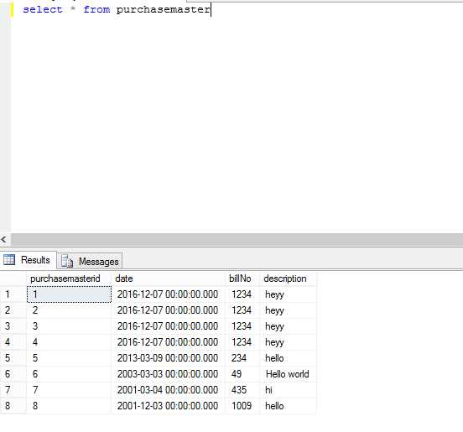

This table is created using query create table purchasemaster(different fields...). Select * from purchasemaster helps to view all the details present in category.

Various fields included in category table are:

Field Datatype Size

purchasemasterId int primary key identity -

date DateTime -

billNo int -

description varchar 100

7.1.Purchase details:

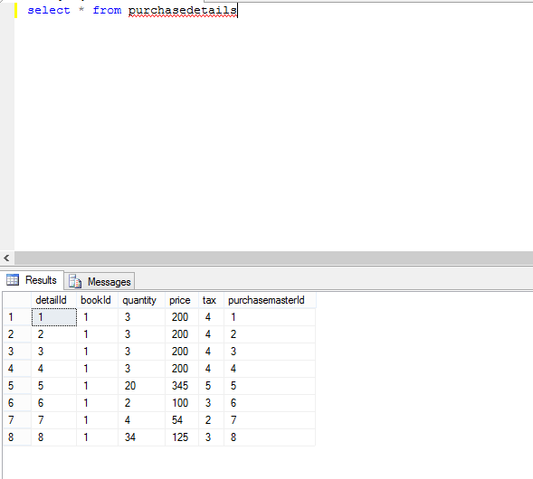

This table is created using query create table purchasedetails(different fields...). Select * from purchasedetails helps to view all the details present in category.

Various fields included in category table are:

Field Datatype Size

detailId int primary key identity -

bookId int references books(bookId) -

quantity int -

price float -

tax float -

purchasemasterId int references purchasemaster(purchasemasterId)

8. SALES:

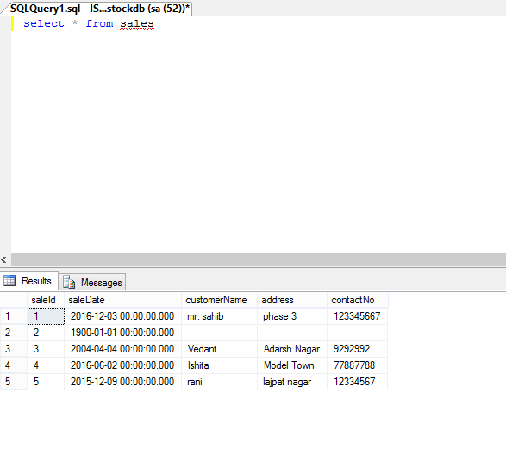

This table is created using query create table sales(different fields...). Select * from sales helps to view all the details present in category.

Various fields included in category table are:

Field Datatype Size

saleId int primary key identity -

saleDate DateTime -

customerName varchar 20

address varchar 100

contactNo varchar 10

Sales Details:

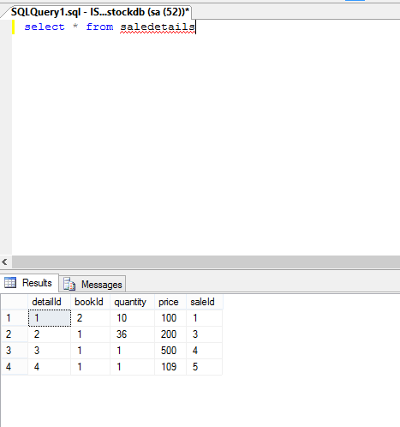

This table is created using query create table saleDetails (different fields...). Select * from saleDetails helps to view all the details present in category.

Various fields included in category table are:

Field Datatype Size

detailId int primary key identity -

bookId int references books(bookId) -

quantity int -

price float -

saleId int references sales(saleId) -

9 PAYMENTS:

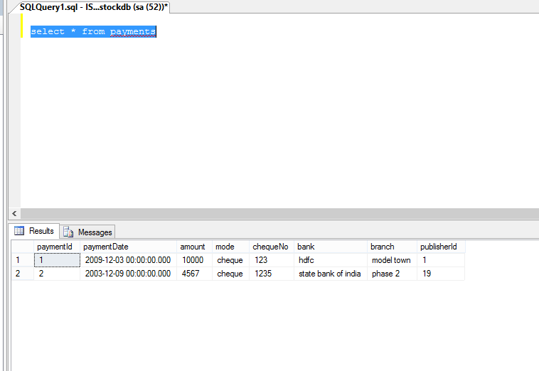

This table is created using query create table payments (different fields...). Select * from payments helps to view all the details present in category.

Different fields are:

Fields Datatype Size

paymentId int primary key identity -

paymentDate DateTime -

amount varchar 20

mode varchar 6

chequeNo int -

bank varchar 50

branch varchar

publisherId int references publishers(publisherId) -

**Chapter -8**

**Bibliography**

* Net Beans
* SQl server
* SPIC
* Mr parminder Singh
* Google.com
* JavaPro